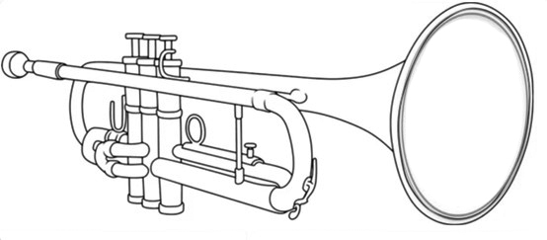

Welcome! Below is a snapshot of repertoire choices for your audition at University of the Pacific. This is by no means a "required" list and you are free to audition with repertoire that is not listed. Please use the list below to help you select contrasting works that best showcases your abilities.
Your audition should reflect your current level of playing. Choose repertoire that highlights your sound, musicianship, and individual strengths. Avoid selecting the most technically difficult pieces solely to impress; instead, focus on works you know well and that showcase your best qualities as a musician. Piano accompaniment is not required.
We want to hear your best sound, experience your musical personality, and understand your creative process. Share your unique perspective—your musical interests, aspirations, and career goals. Show us who you are as an artist and how you think about music. At Pacific, our goal is to help you reach the next level in your musical journey. There are many paths to success, and the most rewarding one begins with being authentically yourself—while remaining open to growth and discovery along the way.
While I recommend supporting your local music stores and purchasing etude books and solo repertoire, most material can also be found on IMSLP. The International Music Score Library Project (IMSLP) is a digital library of public-domain music scores where you can download selected repertoire for free.

Please feel free to contact me at akuhnert@pacific.edu if you have any further questions on audition repertoire.

Recommended Etude Books

Arban - 14 Characteristic Studies
Bitsch - Vingt Études
Bousquet - 36 Celebrated Studies for the Cornet
Brandt - Études for Trumpet
Charlier - 36 Études Transcendantes

Solo Repertoire

Adolphus Hailstork - Sonata for Trumpet and Piano
Arutiunian - Trumpet Concerto
Balay - Petite Piece Concertante
Bohme - Trumpet Concerto
Bolling- Toot Suite
Carnival of Venice or one of Clarke's Cornet Solos
Enesco - Legende
Geodicke - Concert Etude
Haydn - Trumpet Concerto
Henze - Sonatina
Hindemith - Sonata
Honeggar - Intrada
Hummel - Trumpet Concerto
Jolivet - Concertino
Kennan - Sonata
Levy - Grand Russian Fantasia
Libby Larsen - Fanfare for the Women
Neruda - Trumpet Concerto
Otto Ketting - Intrada
Pakhmutova - Concerto for Trumpet
Rodrigo - Concerto De Aranjuez
Tomasi - Concerto
Tomasi - Tryptych
Ulysses Kay - Tromba

Piccolo concertos: Telemann, Molter, Fasch, Marcello, Purcell, Torelli, Handel, etc.

